|  |  |  |  |  |  |
| --- | --- | --- | --- | --- | --- |
| Date | 13-Dec-22 | | | Tester Name | Mayuri Patel |
| Environment | Penfax - Test | | | Login used |  |
| Operating System | Select OS | Version: | Update: | | |
| Software Used | Select Software | Version: | Update: | | |
| Select Software | Version: | Update: | | |
| Release version | 22.4.1 | | | | |
| Title |  | | | | |
| Test Type | Regression | | | | |
| Test Scenario | Process PEPP Cap stock Report | | | | |
|  |  | | | | |
| Expected Results |  | | | | |
| Pass/Fail | Pass | | | JIRA# | N/A |

Describe your steps with screenshots:

Go to Batch Processes

Enter Batch Process type to Process Investment Transactions and search

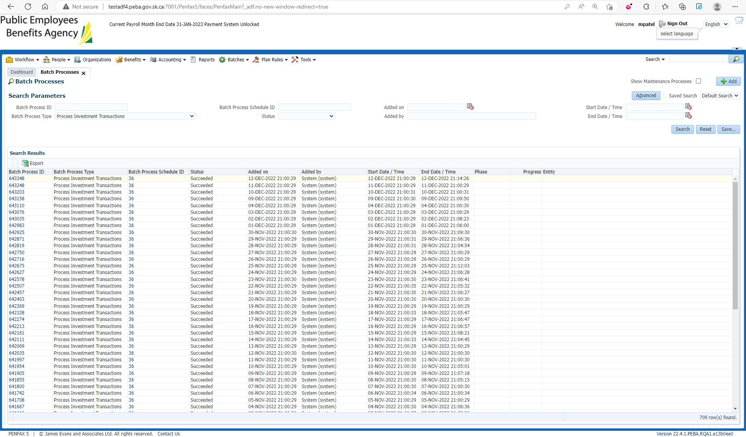

Select the recent Batch Process ID

Under Files Tab Cap Stock Report for that date is saved

Download and open that Report

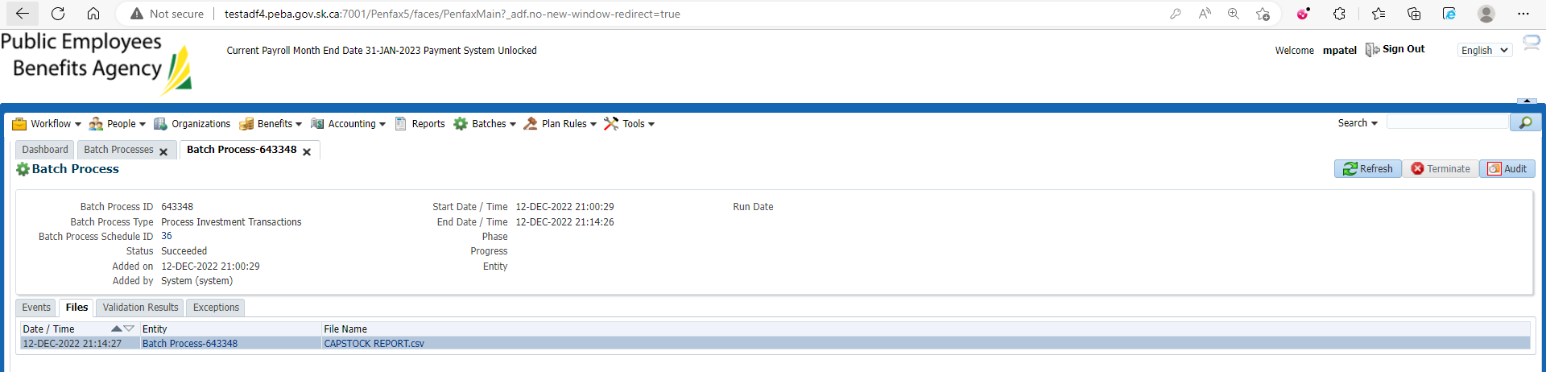

Go to Batch Processes Again

Enter Batch Process Type to PEPP Valuation report and Search

Select the same date Valuation Report that chosen for the Cap stock report to match for the values

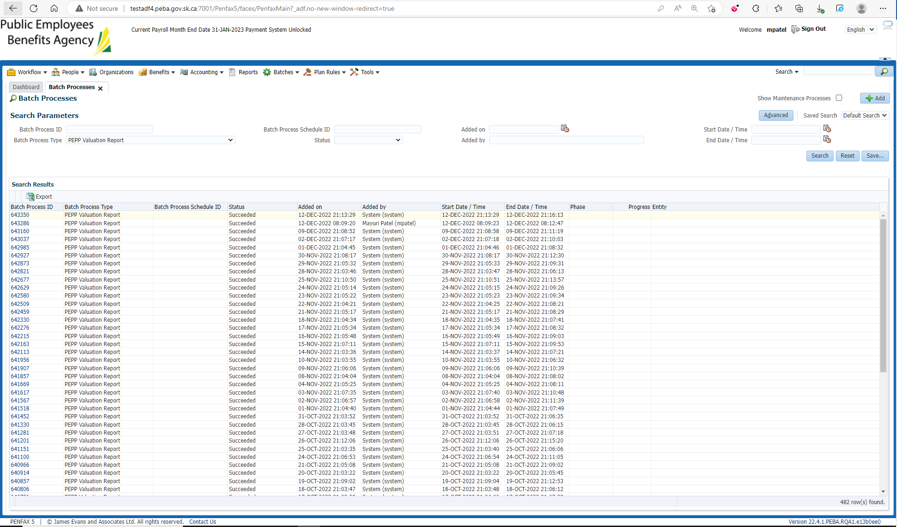

Under Files tab PEPP Valuation Report is there

Download and Open PEPP Valuation Report

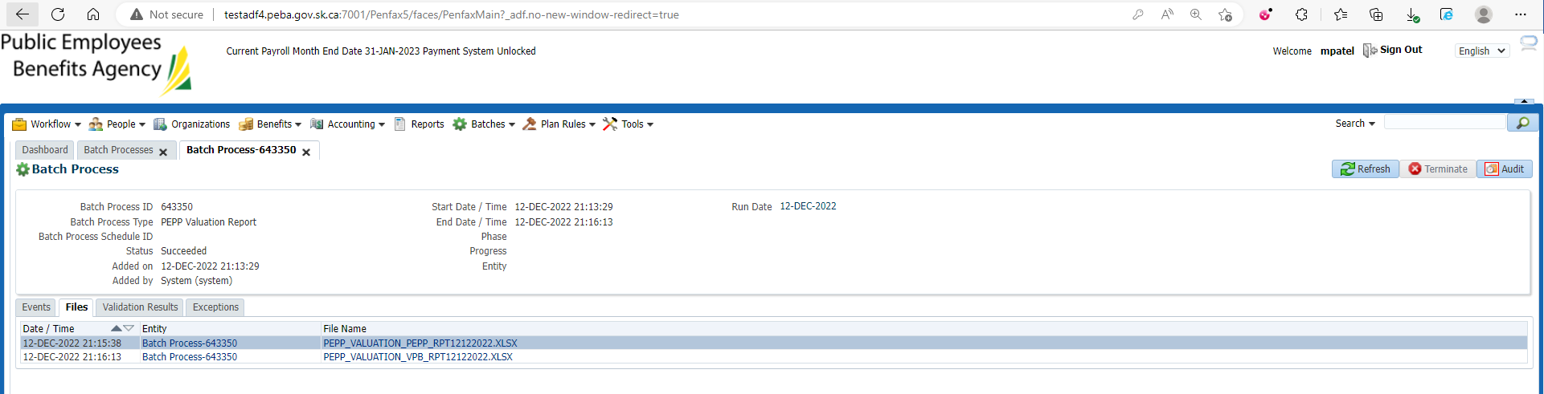

Match the Total units in the Valuation report (Section Twelve) with the units in the Cap stock Report

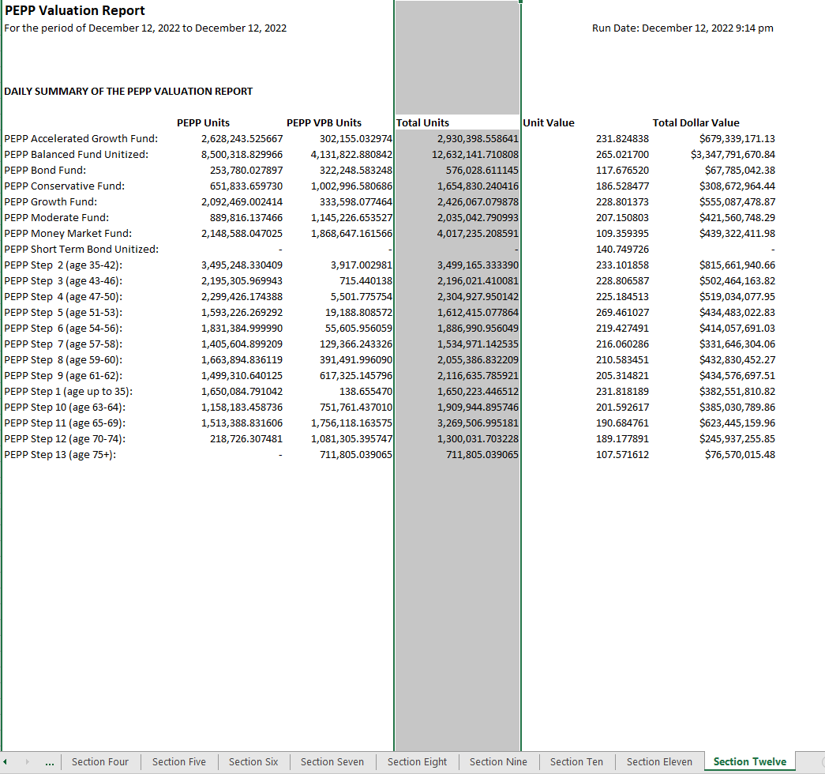

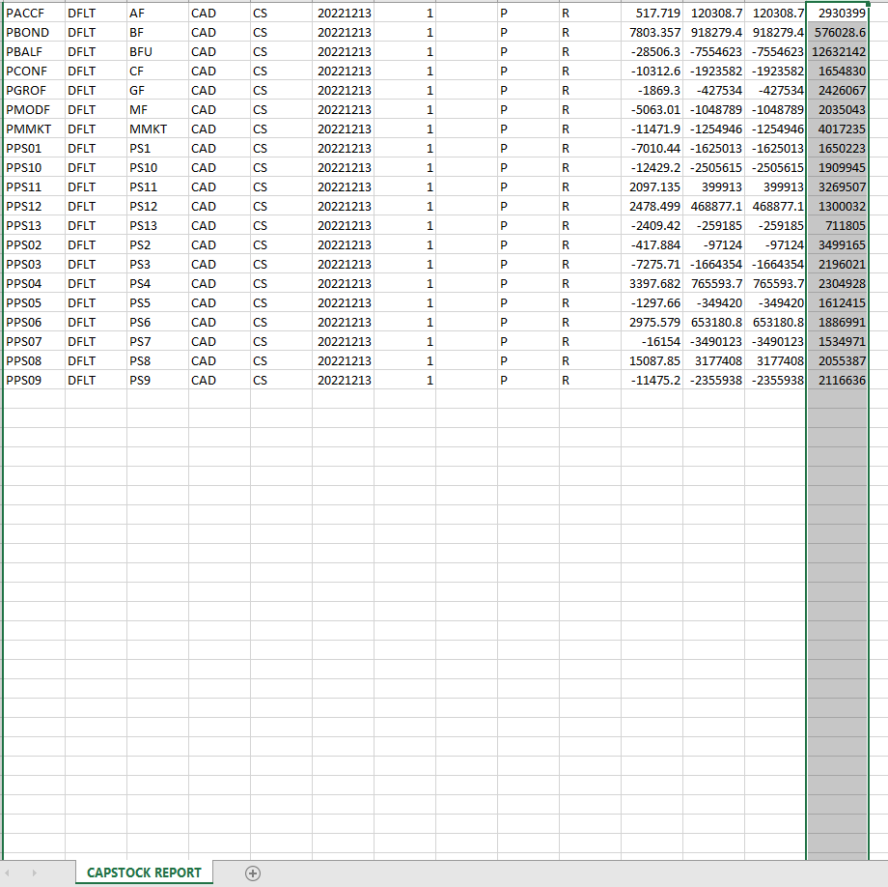

Both the reports Valuation and Cap stock are saved at H:\Quality Assurance\Prod Apps\Testing Management\Regression Testing\Nov 2022 - PENFAX 22.4.1 Release\PEPP\Test Results\E15 Reports